**What does a data scientist do?**

Clearing data and getting data ready to actually be good enough to be trust worthy

Sometimes, it would be a big data problem which you will have to parse the data into various algorithms and then make sense out of it.

This is on a day to day basis.

**What kind of person succeds as a data scientist?**

The curiosity

Put that data into visualization

Adapt to new technologies

Analyzing data

**What skills does a data scientist need?**

Math

Soft skill-you would need to be able to communicate your findings to people who might not necessarily have mathematical background you have and you need to justify your findings to people who are outside your field of expertise.

R

Python

Visualization tool

Gather -> clean -> analyse (demorcratizing)

**Getting Started with Data**

What actuadlly is data

Categorizing the data

1. Temporal
2. Text
3. Numeric- 1) continuous 2) discrete

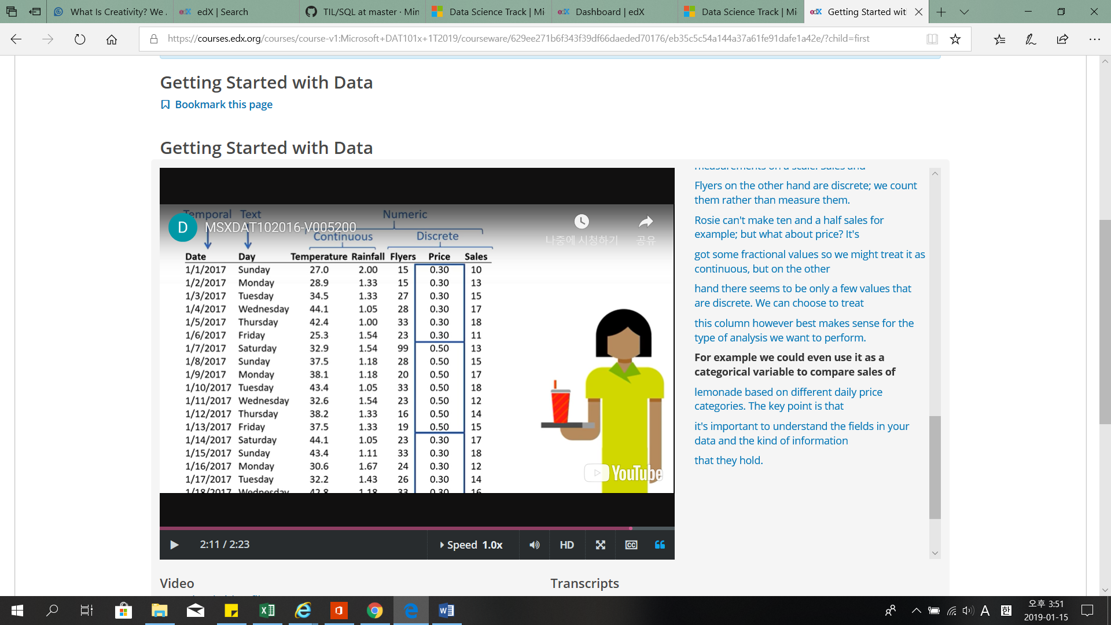

**Sorting and Filtering Data**

Outliers

**Derived Data**

You are not limited to the data fields that exist in your data set.

You can extend your analysis by calculating derived values from the existing data.

For example, you can multiply the daily price by the number of sales made on that day to create a new derived field containing the revenue for that day.

**Highlighting Data**

Heat map visualization

It’s usually used with continuous numerical data to compare values so that the higher the value, the higher the color intensity used to highlight it.

.